LIP 126
Topic: Fermentation Friday 3.0 Fizzy Salsa
“Fermentation Fridays” taught by Chef Dani Chavez-Bello.
Link to recipes: https://youtube.com/playlist?list=PLeX0W94H3mZQLk4WUHTS9Mjp6TqAEUcC6
More and more science is being exposed on the link between gut health and brain health. The gut is often called a "second brain" because it produces many of the same neurotransmitters as the brain does, including serotonin, dopamine, and gamma-aminobutyric acid, all of which play a key role in regulating mood and are a part of a thriving microbiome.
One of the best ways to promote a healthy microbiome is to regularly add fermented foods into your diet. Fermentation is also easy and safe to do at home with simple direction—this series will help get you set up with the basics of fermentation and the skills to build it into your weekly routine.
Fizzy Salsa Ingredients: 32 oz mason jar; 1 pack of cherry tomatoes; 1 onion; 4 garlic cloves; 1 small cucumber; 1 plain yogurt or small bottle of plain kefir (greek yogurt is ok, should contain live cultures and no flavoring like Siggis, Chobani, etc); Salt
Preparation: Peel the onion and cut in half, put the flat surface on the cutting board and slice it thin, slice the rest of the ingredients except for the tomatoes, cut them in half. In a bowl mix all of them together and add some salt, put them in mason jar and add kefir/yogurt.
Wait three days to eat.
Timeline
0:00 – Intro
3:30 – The recipe (shown above)
4:45 – What is Kefir?
5:45 – How long does it take; using yogurt/kefir to ferment
6:40 – Dani slices up the ingredients
10:25 – What are alliums?
11:15 – Next step > Put it in a small bowl
13:35 – The finished product
14:25 – Other easy recipes with yogurt
16:00 – Let’s talk about honey
19:25 – More on the salsa; can go a few weeks before refrigerating
20:35 – Honey is better than sugar and more questions on fermentation
23:45 – Dani’s science lesson and a taste test
29:55 – Cider vs Beer and more lessons
36:40 – Five benefits from fermented food
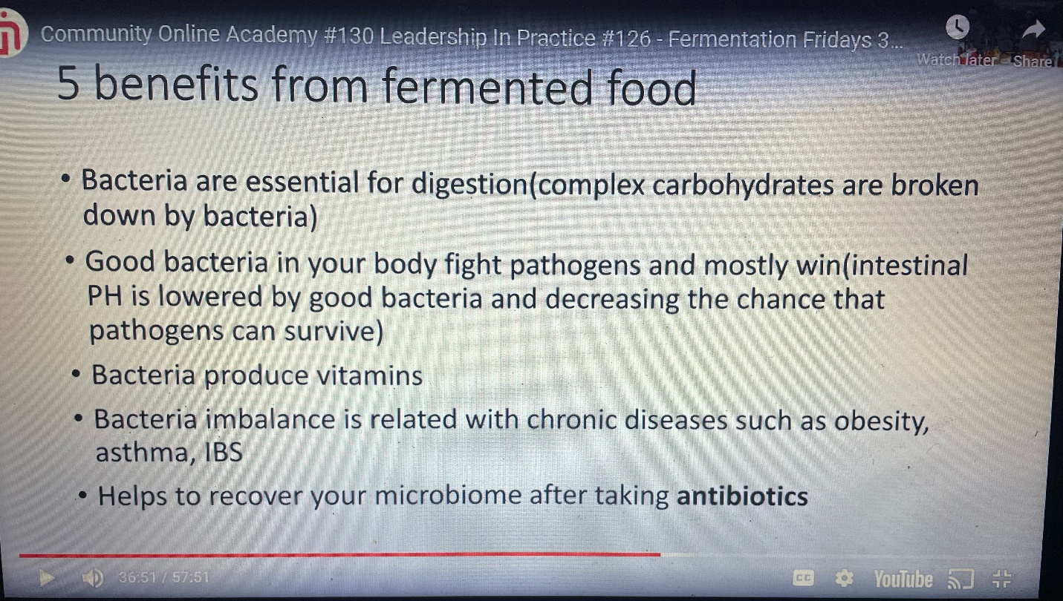
41:00 – How gut bacteria affects the brain and body
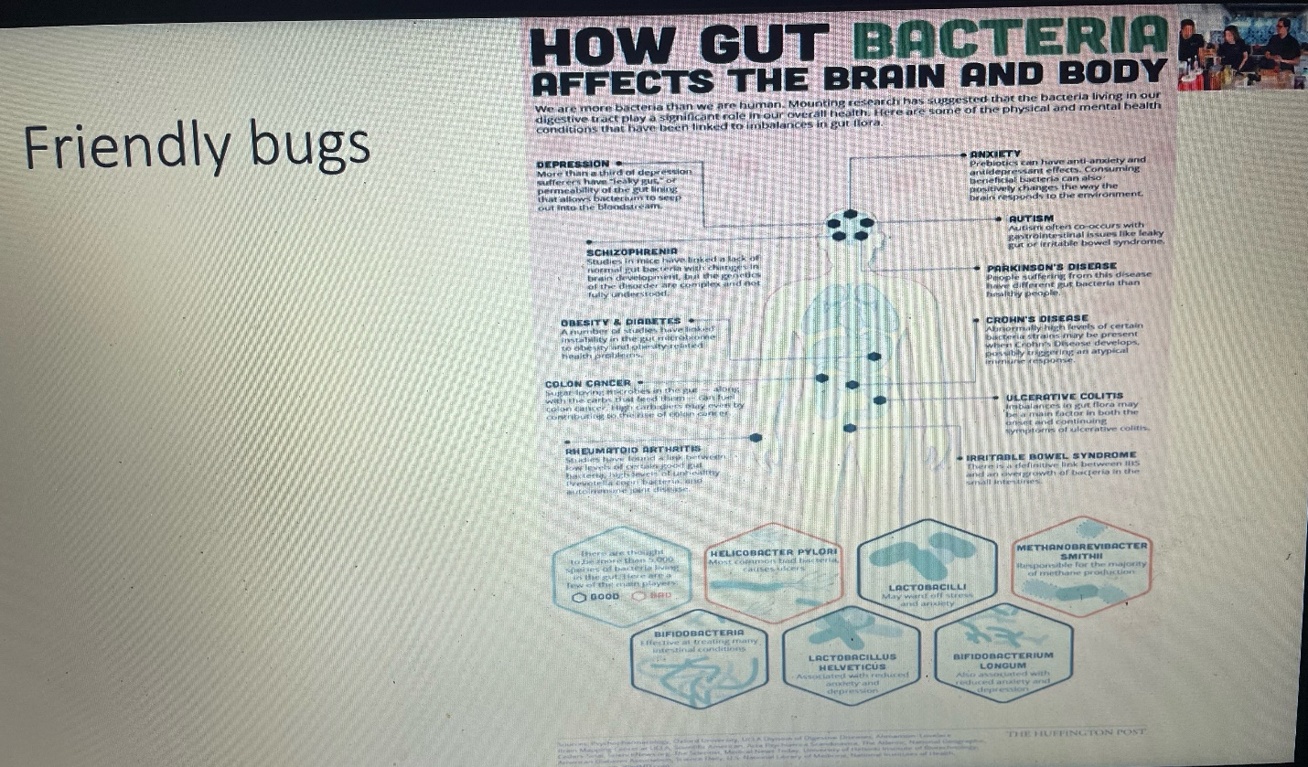
42:15 – The fermented apple and Koji Master
45:50 – A habit worksheet; eating in a community; working out as a community
54:00 – Closing remarks on leadership and decision making
Notable mentions
Alliums: Allium Vegetables: 5 Reasons to Eat More of These Amazing Foods! (foodrevolution.org)
Maria Gloria Dominguez-Bello: Maria Gloria Dominguez Bello Department of Biochemistry and Microbiology at Rutgers SEBS
Martin Blaser: Martin J. Blaser | Rutgers University Microbiome Program
Dick Parsons: How Dick Parsons overcame racism to become one of America's first black CEOs - CNN

